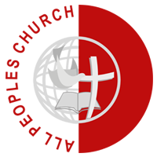
Prospective Employee
Personal Statement
All Peoples Church & World Outreach
#319, 2nd Floor, 7th Main, HRBR Layout, 2nd Block, Kalyan Nagar, Bangalore 560 043, INDIA
Phone: +91-80-65970617 | +91-80-25452617

Date: please enter date here
Completed By: please enter your name here

APC…among the happiest places to work!

Personal Life Vision

Please state your personal life vision (3-5 sentences or less)

Please state how working at APC can help you work towards fulfilling your personal life vision (5 sentences or less)?

Personal TESTIMONY

Please share your testimony of when and how you came to personal faith in Jesus Christ as your Savior and Lord (300 words or less).

Please share a brief about your personal spiritual journey since coming to faith in Jesus Christ (300 words or less).

Christian Ministry involvement

Please describe your involvement in christian ministry, either as a volunteer or staff, in a local church or Christian organization. Please indicate approximate start and end dates, and the work you were involved in.

Christian Ministry References

Please include any references (name, email id, mobile) whom we can contact to speak about your involvement in Christian ministry, personal spiritual life and testimony. Pastoral references preferred (300 words or less).

